Lab 6 Tasks - BFS Implementations with Explanations

# Task 1: BFS without Queue & without Node

This program performs Breadth-First Search (BFS) without using an explicit queue or Node class.  
  
Steps:  
1. We create a graph using a dictionary (adjacency list).  
2. Initialize a list `to_visit` with the starting node.  
3. Use manual list slicing to remove the first element (mimicking queue behavior).  
4. Visit nodes level by level and mark them as visited.

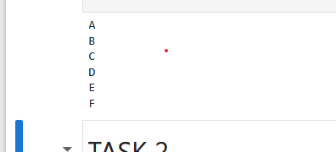

# Task 2: BFS with Queue & Node

This program performs Breadth-First Search (BFS) using a Queue and Node class.  
  
Steps:  
1. Define a Node class with a value and list of adjacent nodes.  
2. Use a real queue (using deque from collections module).  
3. Start from the root node, visit it, and enqueue its unvisited neighbors.  
4. Continue until the queue is empty.

